TUTORIAL 3.1: VLAN and Inter-VLAN Routing
Question 1 b) (Continued)

- The newly added university’s campus network topology is shown in Figure 1-2. The VLAN information is shown in Table 1-2. As for now, SW1 and SW3 have been configured. You are required to suggest configurations for SW2 and R1 based on the requirements needed.

Requirements:
  - Use the VLAN information shown in Table 1-2.
  - Both VLANs are able to communicate.
  - Allow all VLANs in the trunk links.
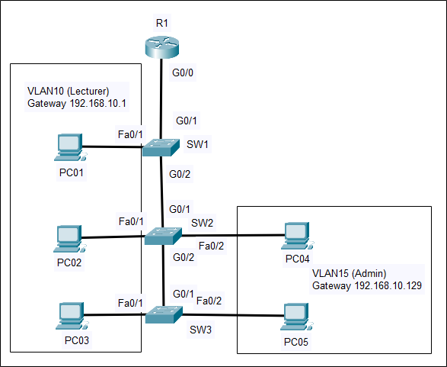
Figure 1-2: Campus Network Topology Table 1-2: VLAN Information

VLAN ID | VLAN Name | Network Address
VLAN 10 | Lecturer | 192.168.10.0 /25
VLAN 15 | Admin | 192.168.10.128 /25
(11 marks)

SW2 | vlan 10  name Lecturer  vlan 15  name Admin  int fa0/1  switchport mode access  switchport access vlan 10  int fa0/2  switchport mode access  switchport access vlan 15  int range g0/1-2  switchport mode trunk  switchport trunk allowed vlan 10,15
R1 | int g0/0.10  encapsulation dot1q 10  ip address 192.168.10.1 255.255.255.128  int g0/0.15  encapsulation dot1q 15  ip address 192.168.10.129 255.255.255.128  int g0/0  no shut

